# Pre-requisites:

- Checkout Chromium Code source. See <https://docs.google.com/document/d/1b0mKPVoj_0Y4jvC6f1_EcVpdETRzBfW6YzcmSw691z0/edit>

- Be a member of Chromium-dev Google Group <https://groups.google.com/a/chromium.org/forum/?fromgroups#!forum/chromium-dev>

# Go to <http://developers.google.com/console>

# Click on “Create project...” and enter the name of your project - “My Chromium Build”

# Toggle on the Chrome Remote Desktop API in the Services section

# Click on “Create an OAuth 2.0 client ID” button in the API Access section

# Enter a product name - “My Chrome Remote Desktop” - and click on “Next” button

# Set “Web application” for Application type

# Click on “More options” link

# Set <https://chromoting-oauth.talkgadget.google.com/talkgadget/oauth/chrome-remote-desktop/dev> to “Authorized Redirect URIs”

# Keep empty “Authorized JavaScript Origins”

# Click on “Update” button and you should have something like that in the end

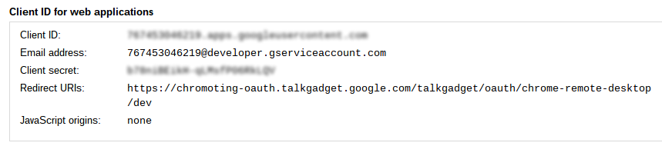

# On your chromium build machine within a X session

cd ~/chromium/src/

# Add these lines at the top of “google_apis/google_api_keys.cc” - <Client ID> and <Client Secret> are in the screenshot above.

#define GOOGLE_CLIENT_ID_REMOTING "<Client ID>"

#define GOOGLE_CLIENT_SECRET_REMOTING "<Client Secret>"

# Build custom Chrome Remote desktop Web App first

./build/gyp_chromium

ninja -C out/Release/ remoting_me2me_host remoting_start_host remoting_webapp

# Extract newly created zip file into a temporary folder

unzip out/Release/remoting-webapp.zip -d /tmp/

# Download a temporary Chromium build because it’s faster than compiling your own

wget -P /tmp/ <http://download-chromium.appspot.com/dl/Linux_x64>

unzip /tmp/Linux_x64 -d /tmp/

# Run chromium

/tmp/chrome-linux/chrome

# Open a tab to “chrome://extensions”

# Toggle on “Developer mode” checkbox

# Click on “Load unpacked extension...” button

# Select /tmp/remoting-webapp/ folder

# Click on “Add” button

# Open a new tab

# Click on the Chromoting App icon

# Follow instructions to authorise the App

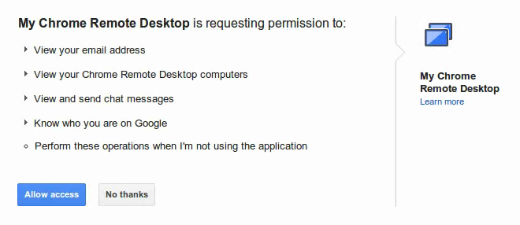

# Build Chrome Remote Desktop Debian Package

sudo apt-get install devscripts

./remoting/host/installer/linux/build-deb.sh

# Install X virtual framebuffer

sudo apt-get install xvfb

# Install Chrome Remote Desktop Debian Package

sudo dpkg -i remoting/host/installer/chrome-remote-desktop_*.deb

# Reload Chromoting Tab

# Click on “Enable remote connections”

# Enter a PIN and validate

# Upload /tmp/remoting-webapp folder to your Google Drive (or anywhere)

# On your Chromebook

# Download uploaded remoting-webapp folder

# Open a tab to “chrome://extensions”

# Toggle on “Developer mode” checkbox

# Click on “Load unpacked extension...” button

# Select remoting-webapp folder location

# Click on “Add” button

# Open a new tab

# Click on the Chromoting App icon

# Follow instructions to authorise the App

# In the end, you should see your linux machine in “My computers”

# Click on the name

# Enter the PIN you chose before

# Woohoo! We did it!

Side tips:

- The Chrome Remote Desktop Service can be controlled via sudo service chrome-remote-desktop stop|start

- Pin the Chromoting App to the launcher and select “Open as a window”

